C:\Users\CHURCH~2\AppData\Local\Temp\ksohtml\wpsAB7F.tmp.png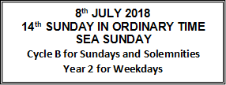**Parish 100 Club**

Congratulations to the winners of the July draw:

£15 – June Bailey, £25 – Christine Hughes, £100 – Pauline Bedford

**Sea Sunday**

Today is Sea Sunday, when the Church prays for all those who live and work at sea. Without them we would not have most of the items we buy in the shops. Today’s Second Collection is for Apostleship of the Sea (AoS), the Church’s official maritime welfare agency. It supports seafarers both practically and spiritually. This collection is vital to enable it to continue its work, so please give generously and remember seafarers in your prayers. Thank you. To donate online please visit [www.apostleshipofthesea.org.uk](http://www.apostleshipofthesea.org.uk).

**Sea Sunday Prayer**

***Our Lady, Star of the Sea***

***Pray for Seafarers***

***Pray for us***

O Mary, Star of the Sea, light of every ocean, guide seafarers across all dark and stormy seas that they may reach the haven of peace and light prepared in Him who calmed the sea. As we set forth upon the oceans of the world and cross deserts of our time, show us, O Mary, the fruit of your womb, for without your Son we are lost. Pray that we will never fail on life’s journey, that in heart and mind, word and deed, in days of turmoil and in days of calm, we will always look to Christ and say, ‘Who is this that even wind and sea obey him?’ Our Lady of Peace, pray for us! Bright Star of the Sea, guide us!

**Saints of the Week**

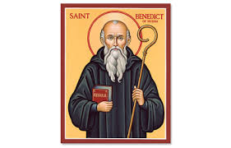 **St Benedict, Abbot - 11th July**

Born at Norcia in Umbria about 480. He studied in Rome, and then turned his back on the world and lived in solitude in Subiaco. Disciples came to him, and he went to Monte Cassino, where he founded a monastery. He wrote his Rule, which established the spirituality and way of life of monastic communities ever since. He died in 547.

**St Henry - 13th July**

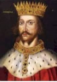Born in 973, Henry became Duke of Bavaria on his father’s death

in 995, and was crowned Holy Roman Emperor in 1014. He was

married, but had no children. He was ardent for the reform of the

Church, took part in synods, founded monasteries, appointed

bishops of integrity. With his wife he lived a semi-monastic life of

prayer and discipline.

***God Bless Fr Tony***

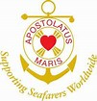

**Tel: 01424 773125**

**e-mail:** [**ourladyimmac@tiscali.co.uk**](mailto:ourladyimmac@tiscali.co.uk)

**Website: battlewithnorthiam.parishportal.net**

**OUR LADY IMMACULATE & ST MICHAEL BATTLE with**

**ST TERESA OF LISIEUX NORTHIAM**

The Presbytery, 14 Mount Street, Battle, East Sussex TN33 0EG

**MASSES FOR THE WEEK: SATURDAY 7th – SATURDAY 14th JULY 2018**

**SAT: 7th** 6.00pm INTENTION OF HEATHER STANDEN

**SUN: 8th** 9.00am JOHN & EILEEN KNOWLES, R.I.P. – ST TERESA’S

10.45am PEOPLE OF THE PARISH – BATTLE

3.00pm CONFIRMATION CEREMONY AT

ST MARY MAGDALENE CHURCH, SEA ROAD, BEXHILL **MON: 9th** 10.00am JOHN AMMON, R.IP.

12noon REQUIEM MASS FOR THE REPOSE OF THE SOUL OF FRANK DOUGLAS – ST TERESA OF LISIEUX

**TUES: 10th** 10.00am INTENTION OF PAT MARSHALL

**WED: 11th** NO MASS

**THURS:12th** 10.00am JOSEPH & JANE KIRGAN, R.I.P. (F.M.)

**FRI: 13th** 10.00am FR EDMUND LOMAN, R.I.P. (F.M.)

**SAT: 14th** 10.00am CELEBRANT’S INTENTION

***Sacrament Reconciliation: Saturday 9.30am – 9.50am***

**Introduction to the Scripture Readings**

**First Reading: Ezekiel 2:2-5**

Whether they listen or not, the rebels will know there is a prophet among them.

**Second Reading: 2 Corinthians 12:7-10**

It is when he is weak that Paul is strong, through the grace of Christ dwelling in him.

**Gospel: Mark 6:1-6**

Jesus is amazed at people’s lack of faith.

**Events and Feast Days This Week**

**Wednesday** is the feast of St Benedict, Abbot.

**Friday** is the memorial of St Henry.

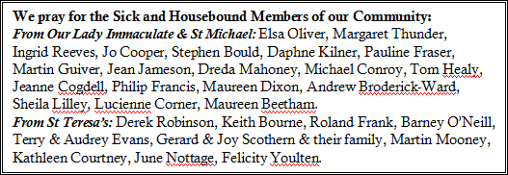**Saturday** is the memorial of St Camillius de Lellis, Priest.

**Offertory**

The collection for the weekend of 30th June & 1st July was £231.80 in Battle and £123.20 in Northiam. Thank you all for your generosity.

**Sacramental Programmes**

**First Communion:**

If you wish to enrol in the First Communion programme for next year, please ask Fr Tony for an application form, or contact the Parish Office.

**Confirmation:**

Please pray for the nine young people of our parish who will be Confirmed on Sunday afternoon at St Mary Magdalene in Bexhill, by Bishop Richard.

We pray for ***Anthony, Emma, Gabriel, Isobel, Phoebe, Julia, Malachy, Delicia, Bertie and their families.***

We welcome our newly confirmed back to Battle at the 6pm Mass next Saturday 14th July, when they will receive their certificates.

**Healing Mass**

Our annual Healing Mass will be on Sunday 29th July at 3pm, at St Teresa’s in Northiam, to coincide with the Diocesan Pilgrimage to Lourdes. The Mass will be followed by a Strawberry Tea. If you need a lift, please write your name on the list at the back of the Church.

**Battle UCM – Union of Catholic Mothers**

Our next meeting will be on Tuesday 17th July, in the Parish rooms where we will have our annual Beetle Drive, we have invited Hollington Foundation as our guests and hope to enjoy a fun afternoon. All ladies of the Parish welcome, for further information please contact Chris 01424 774302 or

Terri 01424 853384.

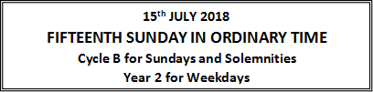

**MASSES FOR THE WEEK: SATURDAY 14th – SUNDAY 22nd JULY 2018**

**SAT: 14th** 6.00pm JOHN LOBO, R.I.P.

**SUN: 15th** 9.00am PATRICIA (INTENTION OF BARNEY & JENNY O’NEILL) – ST TERESA’S

10.45am PEOPLE OF THE PARISH – BATTLE

**MON: 16th** 10.00am HOLY SOULS

**TUES: 17th** 10.00am REV LEONARD TURNER, R.I.P.

**WED: 18th** NO MASS

**THURS:19th** 10.00am CELEBRATION OF HOLY COMMUNION

**FRI: 20th** 10.00am FR JOHN GILLESPIE, R.I.P.

**SAT: 21st** 10.00am CELEBRANT’S INTENTION

6.00pm MAY BARRETT, R.I.P.

**SUN: 22nd** 9.00am DENIS MEARES, R.I.P. – ST TERESA’S

10.45am PEOPLE OF THE PARISH - BATTLE

***Sacrament Reconciliation: Saturday 9.30am – 9.50am***

**Introduction to the Scripture Readings**

**First Reading: Amos 7:12-15**

Amos is being scolded by the people, but he knows what the Lord has asked him to do and he continue his mission.

**Second Reading: Ephesians 1:3-14**

Long before even the world was made, God chose us to be holy and blameless.

**Gospel: Mark 6:7-13**

Jesus sent the twelve apostles out in twos and they drove out many demons and anointed sick people and cured them.

**Events and Feast Days This Week**

**Monday** is the memorial of Our Lady of Mount Carmel.

**Friday** is the memorial of St Apollinaris, Bishop, Martyr.

**Saturday** is the memorial of St Laurence of Brindisi, Priest, Doctor.

**Arundel and Brighton Trust is a Registered Charity No. 252878**